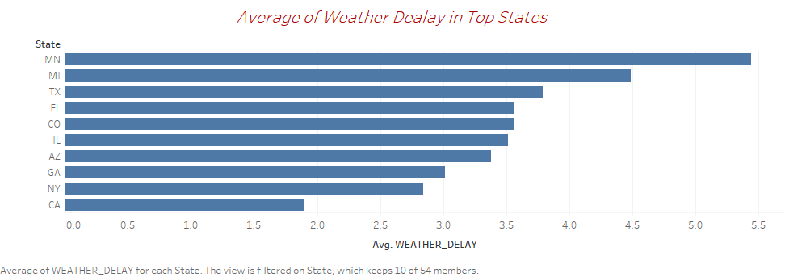

From the bar chart, we can see the where the highest number of weather delays. It appears that Minnesota has the highest numbers because of inclement weather, such as thunderstorm, hurricane, or blizzard. While Michigan has the second highest number of flight delays because of weather. Whereas California has the smallest number of weather delays because it has a Mediterranean-like climate.

Design: I choose the bar view to show the weather delays in the top ten states. Because I selected the top ten the bar chart will be more readable from the viewers.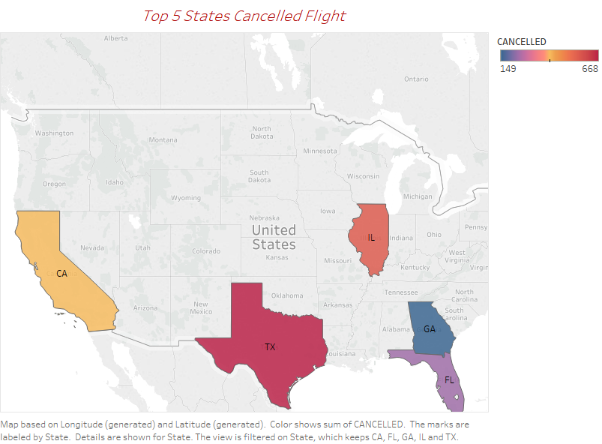

From the map, that shows the top five states have cancelled flights. We can see that Texas has the largest numbers of canceled of flights. Illinois has the second largest numbers of airline flight cancellations. Even though Georgia has the lowest numbers of canceled of flights.

Design: I choose the map for simple view easy to understand. The warm color shows the states that have the highest numbers of airline flight cancellations and the cool color presented the states that have the lowest numbers of canceled of flights.

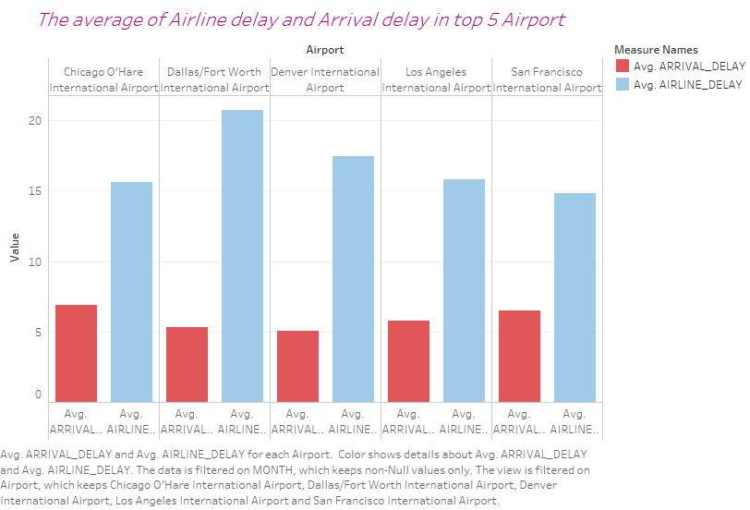

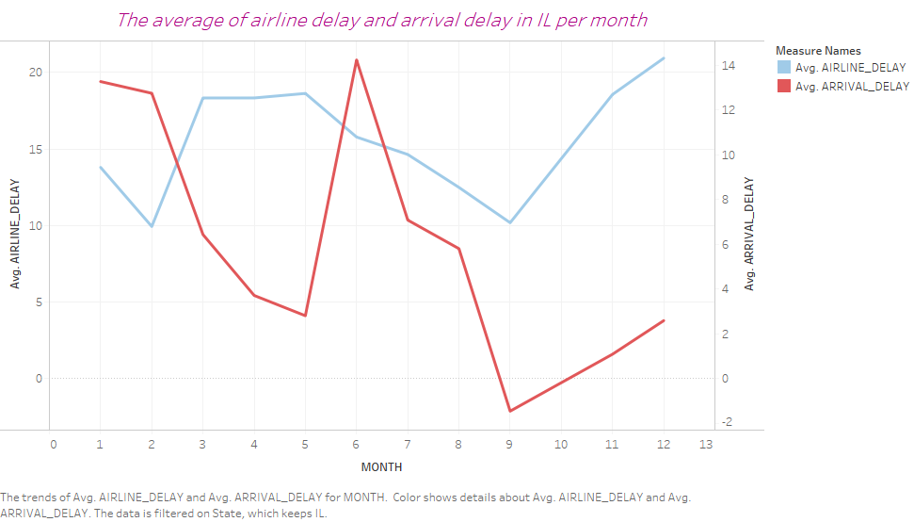

Dashboard:

From this dashboard, I combine two visualizations, the one with the average of Airline delay and Arrival delay in top 5 Airport and the other is showing the average of Airline delay and Arrival delay in Illinois state. In both visualizations, the blue color represents the airline delay and red color represents the arrival delay. In the side-by-side bars, we can see that Chicago O'Hare International Airport and San Francisco International Airport have the highest numbers of arrival delay. Meanwhile, Dallas/Fort Worth International Airport and Denver International Airport have the highest number of the airline delay. In the line chart that the average of airline delay and arrival delay in IL. we can see that June has the highest numbers of arrival delay. Whereas on December has the highest numbers of the airline delay. On September, was the lowest number of the airline delay and arrival delay.